Challenge 1:Temperature Conversion

In this program, you are expected to design and code a program to convert temperature from celsius to fahrenheit and fahrenheit to celsius.

Design the interface using tkinter as one below:

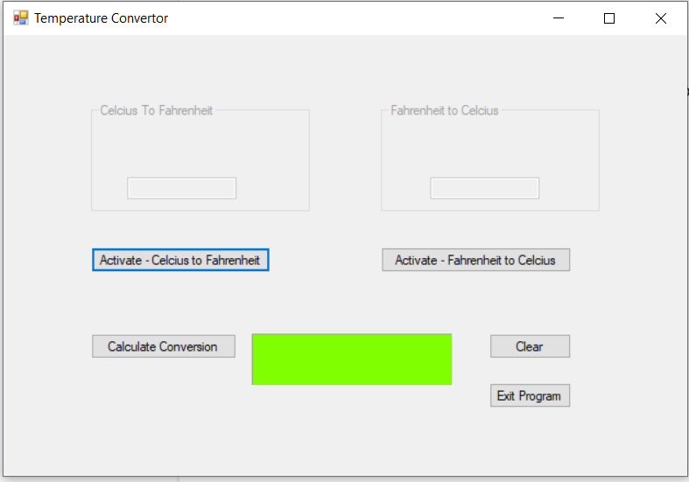

You are free to improve the design and make it more appealing.

In doing the conversions, use the formulas below:

**Celsius to Fahrenheit Conversion**

[°F] = [°C] × 9/5 + 32

**Fahrenheit to Celsius Conversion**

[°C] = ([°F] − 32) × 5/9

1.1 Design the interface as one above and implement your own colours.(10)

1.2 When Activate-Celcius to Fahrenheit button is clicked, the textbox for Celcius to Fahrenheit must be activated and allow you to enter the degrees celsius in the textbox. Click calculate conversion to display the answer in the label in green. (10)

1.3 When Activate- Fahrenheit to Celsius button is clicked, the textbox for Fahrenheit to Celcius must be activated and allow you to enter the degrees fahrenheit in the textbox. Click calculate conversion to display the answer in the label in green. (10)

Implement functions to do the conversions.

1.4 When the button clear is clicked, call the clear function to clear the textboxes and the label for the answer. (10)

1.5 When the button exit is clicked, call a function to close the program (10)

1.6 Add comments to your program. (5)

1.7 Convert your program to an executable file for packaging. (5)